VPC task-1

1) Create VPC with 2 private and 2 public subnets.

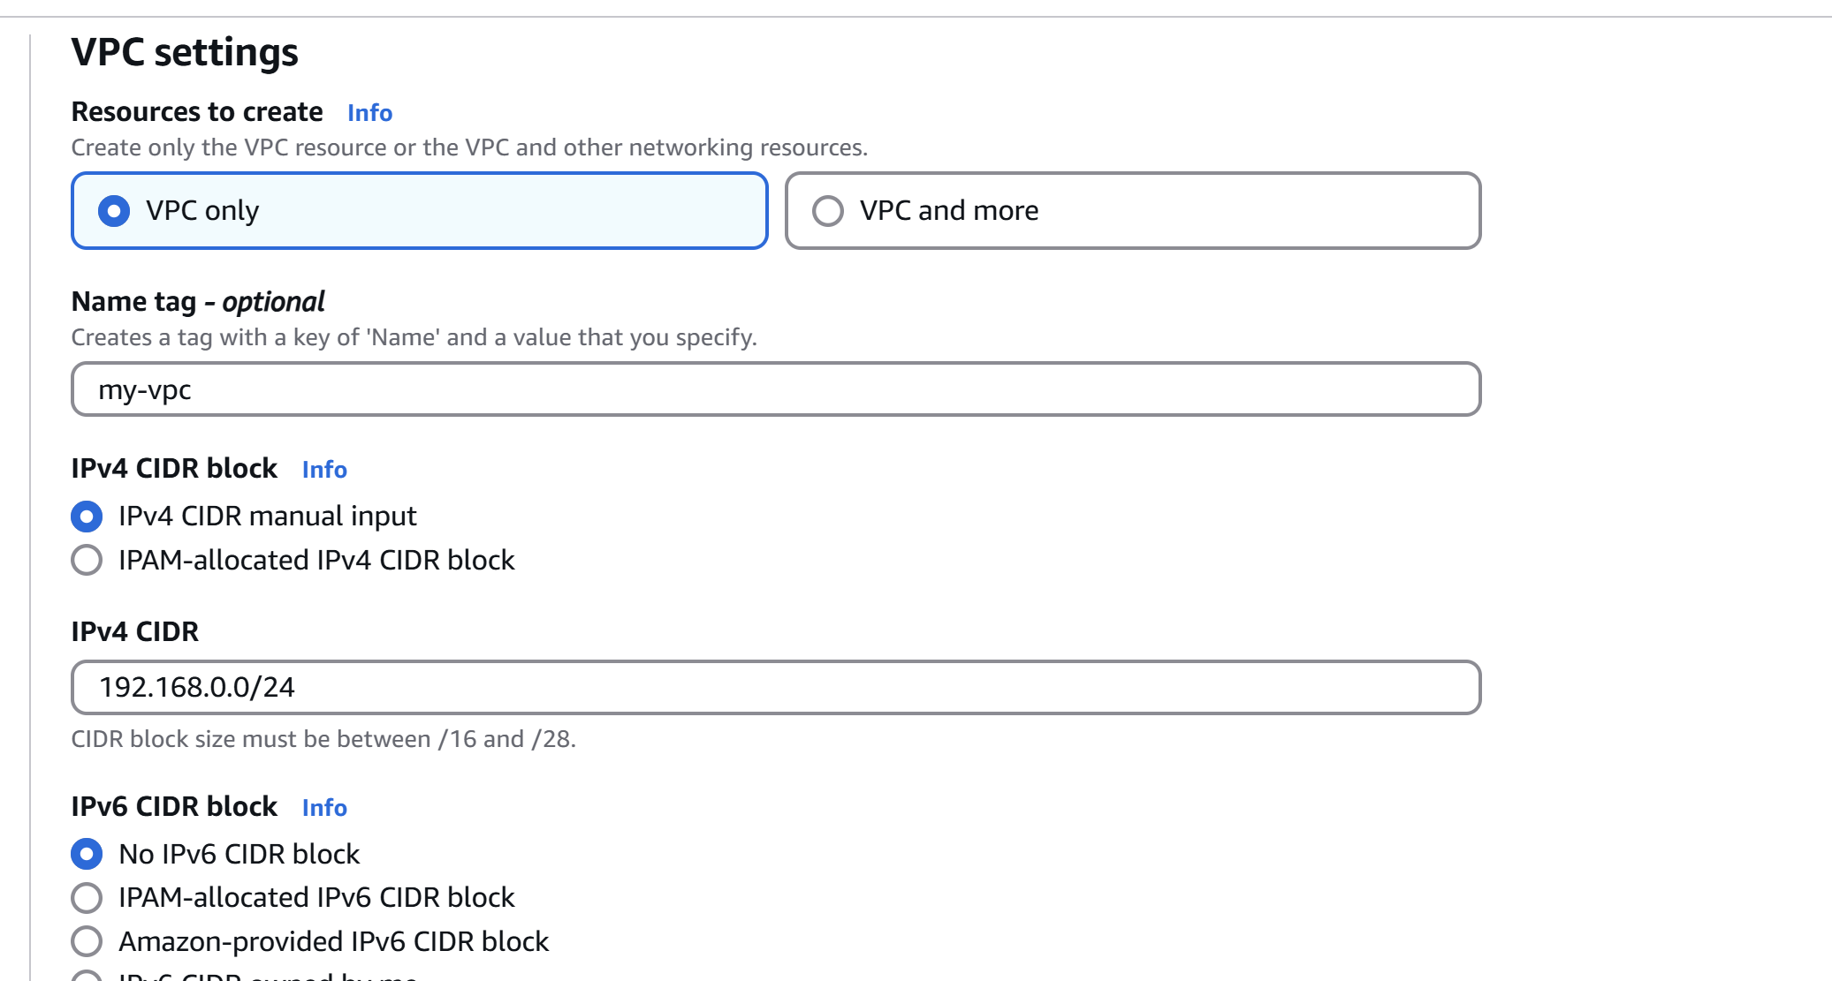

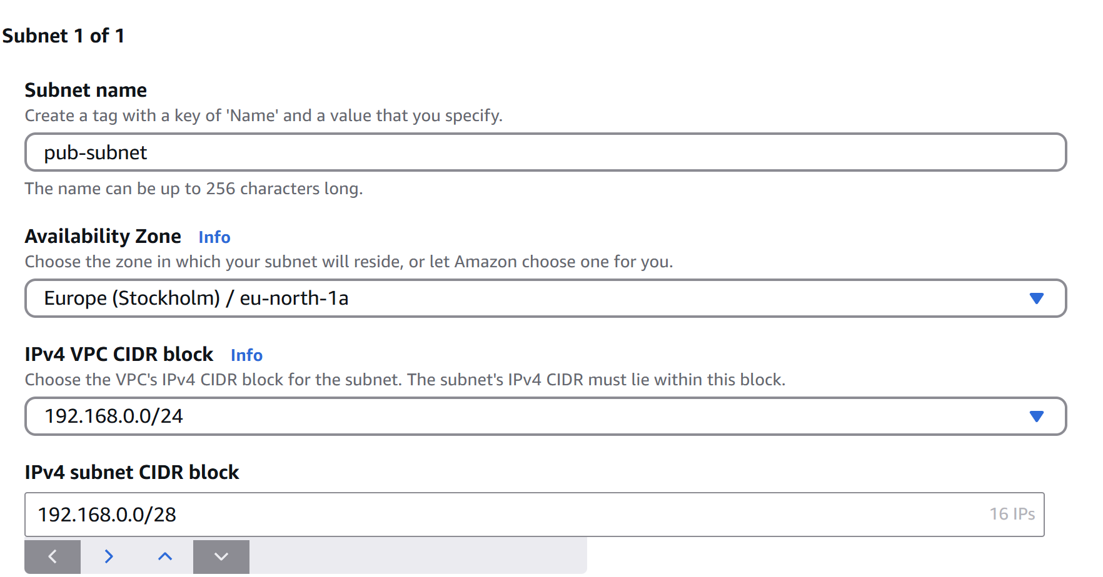

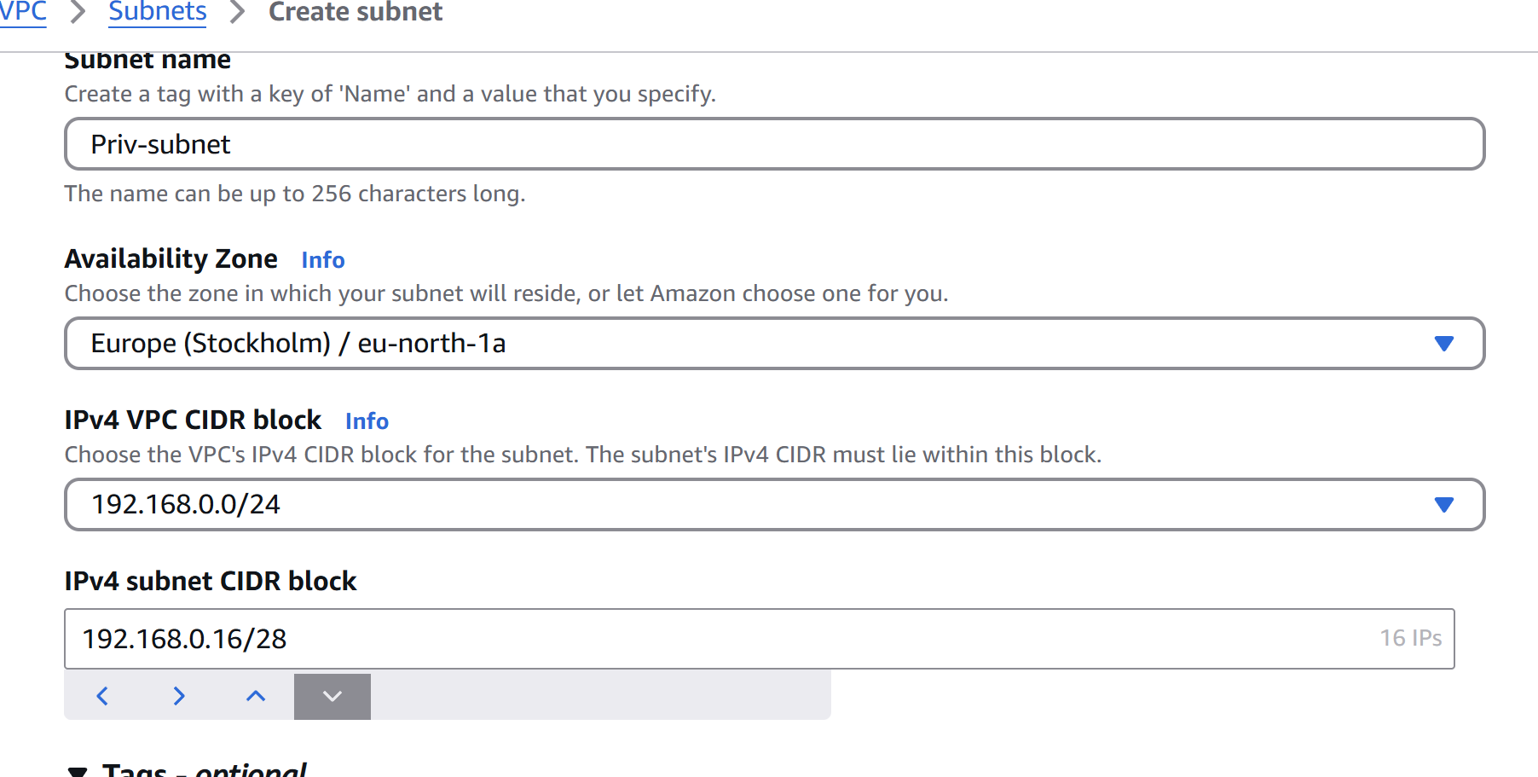



2) Enable DNS Hostname in VPC

* + **Go to the VPC Dashboard** in the AWS Console.
  + Select your VPC
  + Click on the **“Actions”** dropdown.
  + Select **“Edit VPC settings”**.
* **Enable DNS hostnames**
* Click **Save changes**.

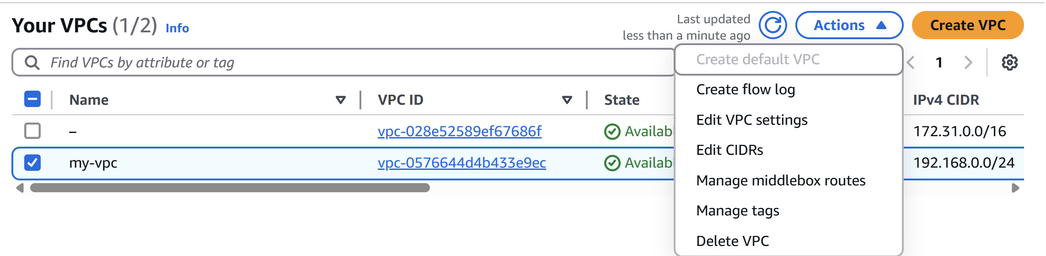

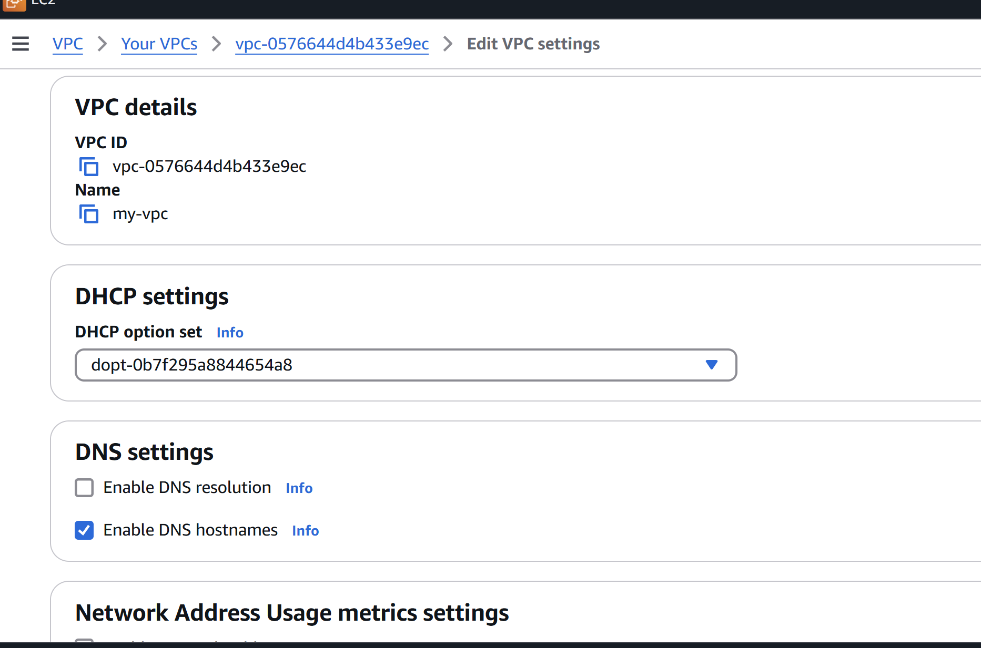

3) Enable Auto Assign Public ip in 2 public subnets

* Go to **VPC Dashboard** → **Subnets**.
* Select **public subnets**.
* Click **“Actions”**.
* Click **“Edit subnet settings”**.
* Under **“Auto-assign IP settings”**

**Enable auto-assign public IPv4 address**

* Click **Save changes.**

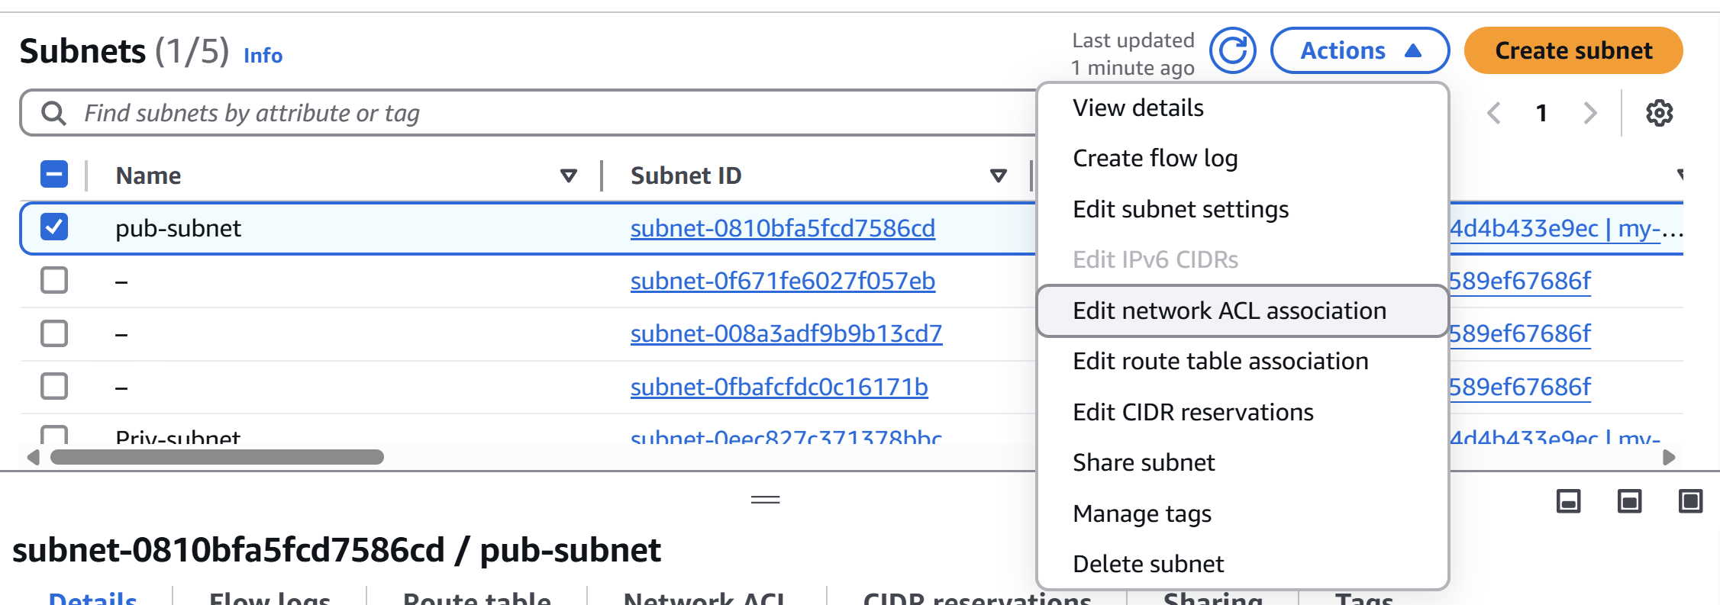

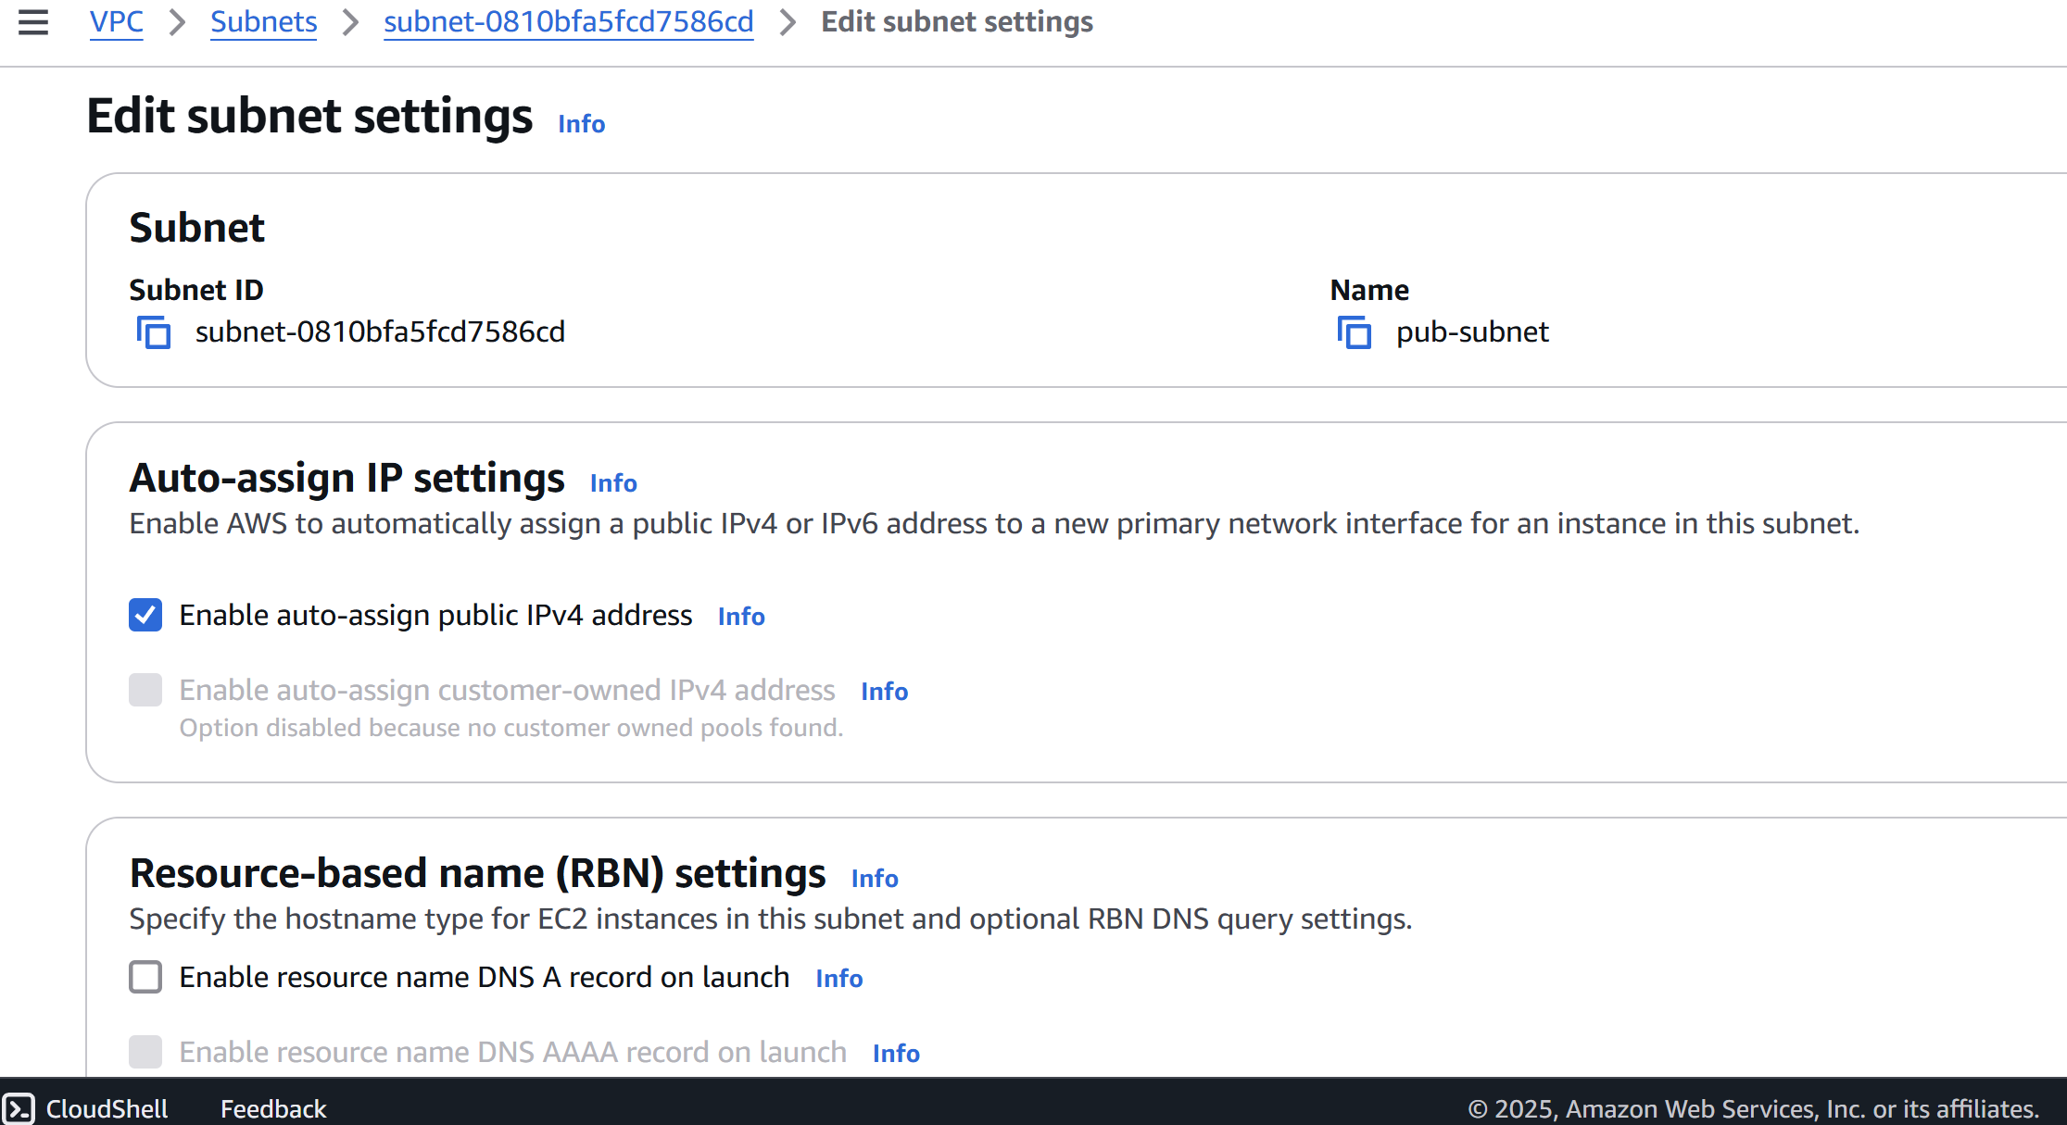

4) Add 2 private subnets in private route table

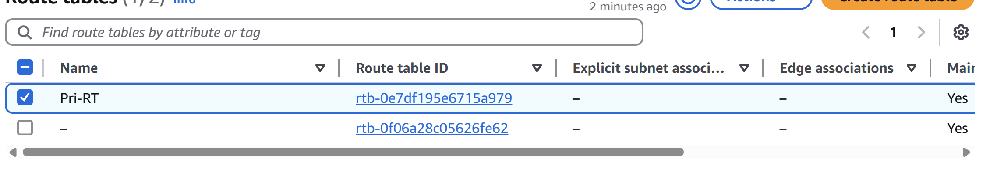

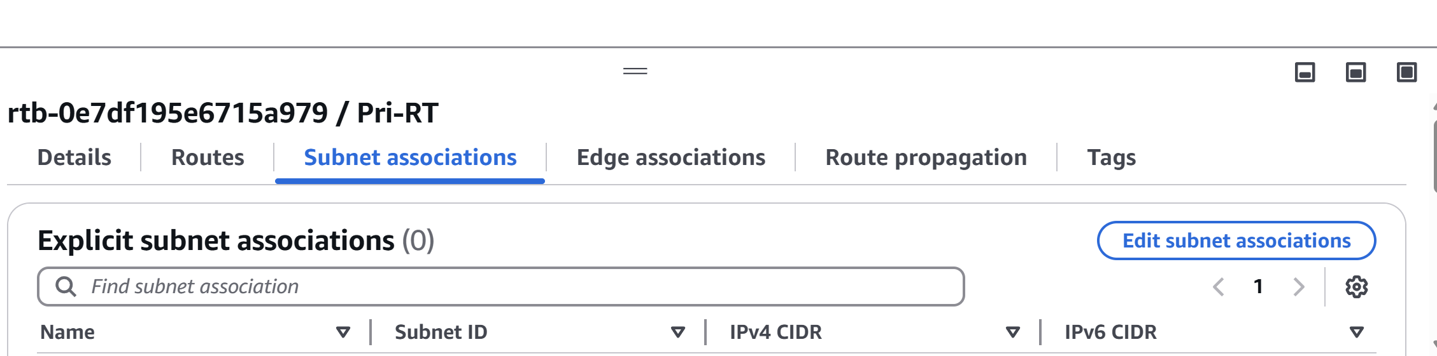

5) Add 2 public subnets in public route table

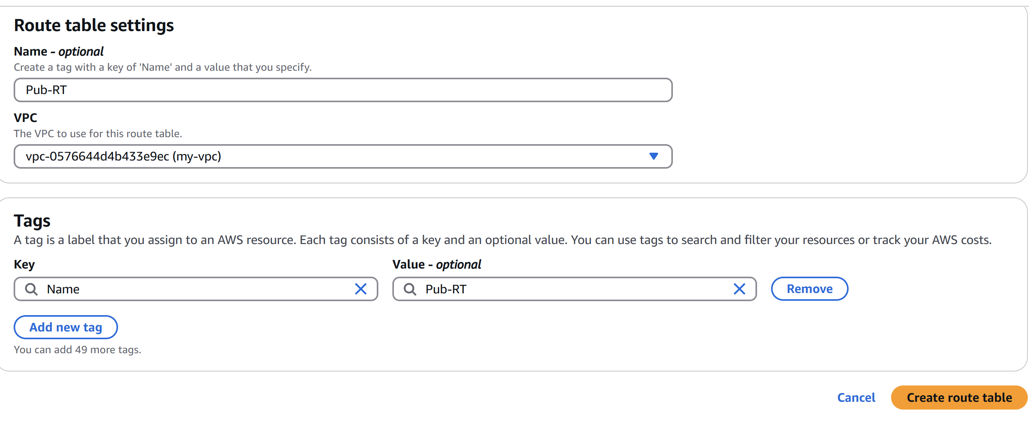

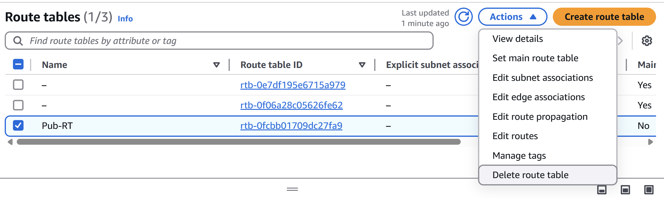

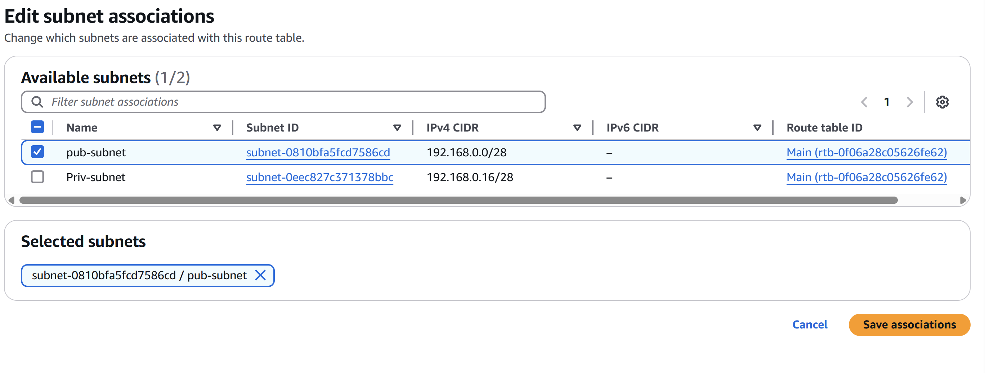

6) Public route table will have the routes to internet and local

* Create a instance with Vpc

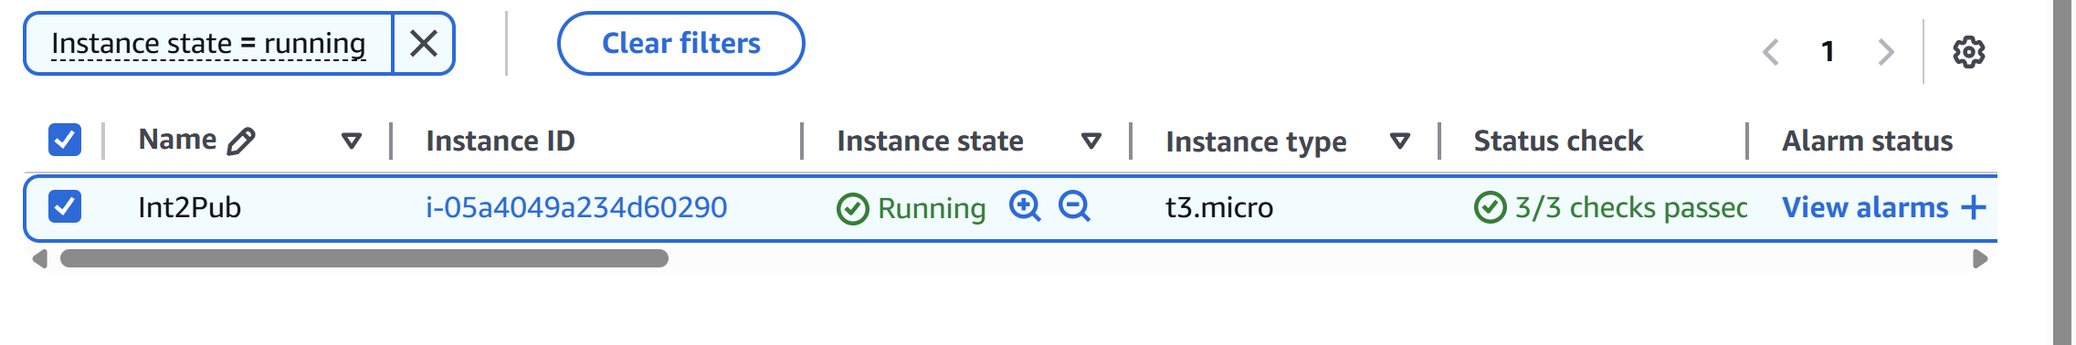

* Then connect the Ec2 server with the instance

**ssh -i "Aws_key.pem"** [**ec2-user@51.21.196.42**](mailto:ec2-user@51.21.196.42)

* Then the server will connect
* Then check with the internet access by the comman **ping google.com**

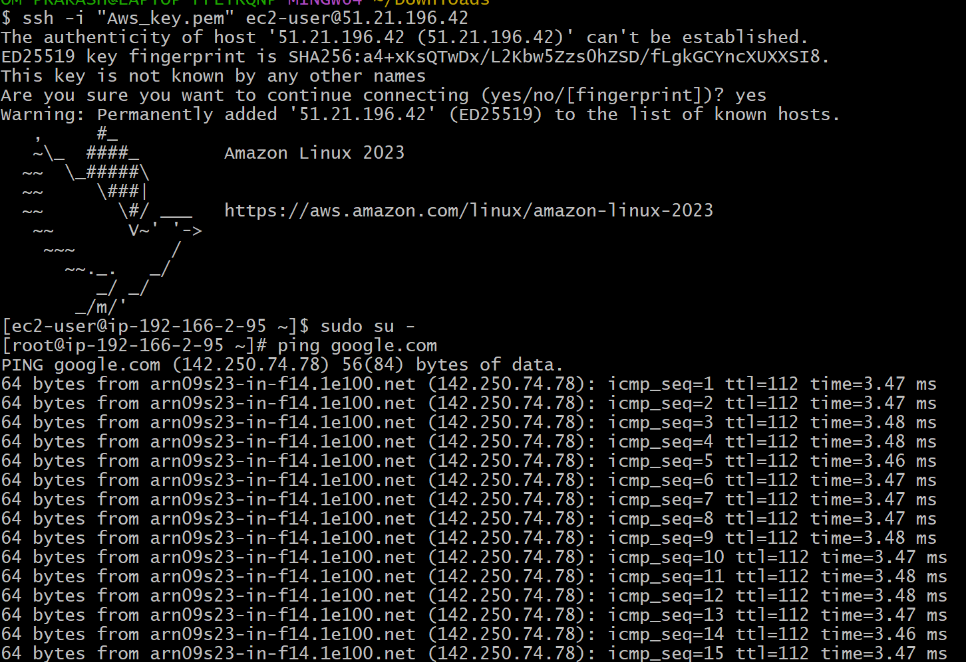

7) Create Ec2 in public subnet with t2micro and install php

* Connect to Ec2 instance
* To install PHP
* **sudo dnf install -y php php-cli php-mysqlnd httpd**
* **sudo systemctl start httpd**
* **sudo systemctl enable httpd**
* To create a test PHP page

**echo "<?php phpinfo(); ?>" | sudo tee /var/www/html/info.php**

* **http://<your-public-ip>/info.php**

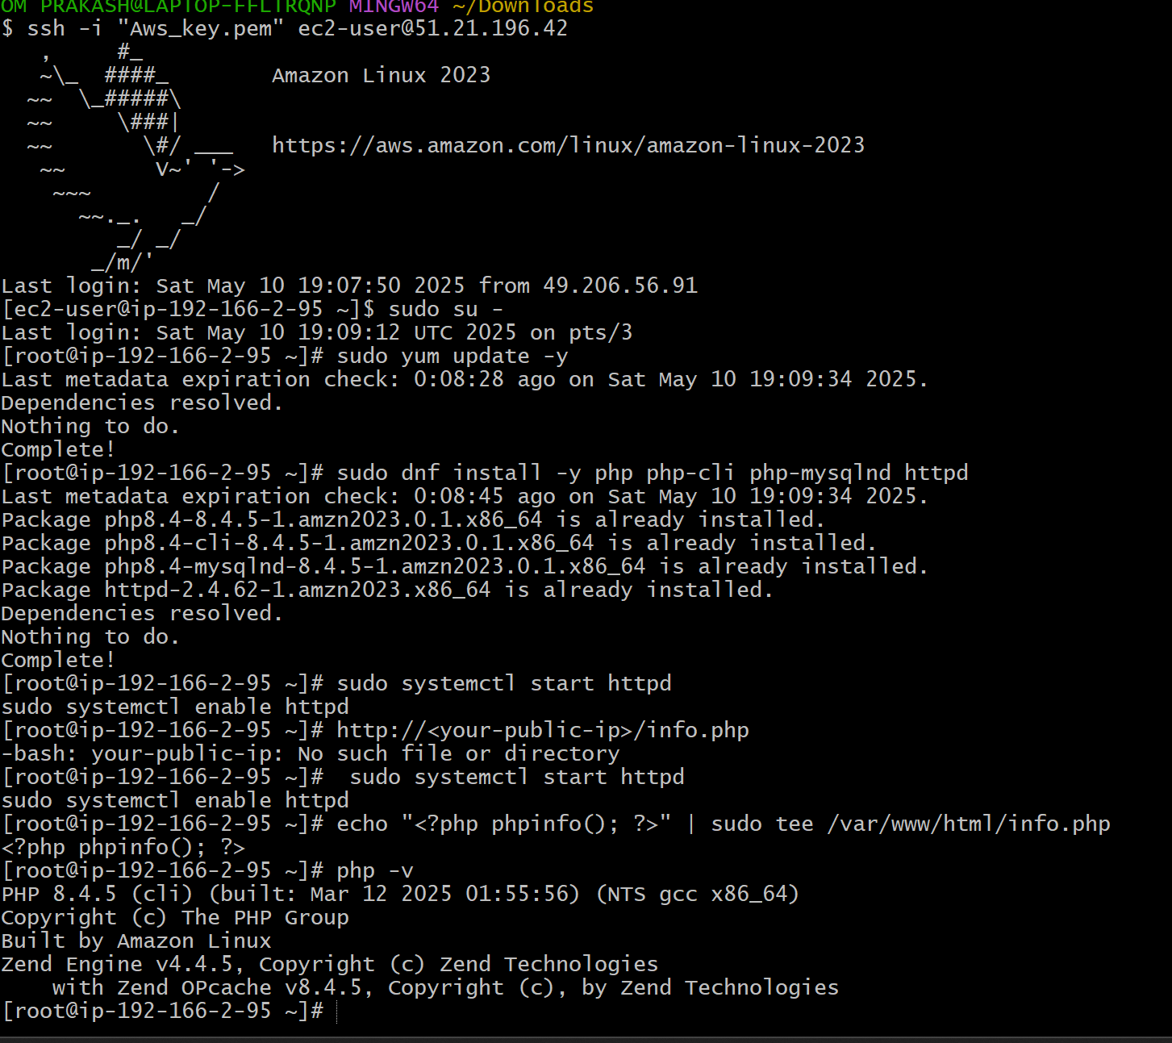

8) Configure Nat gateway in public subnet and connect to private Instance

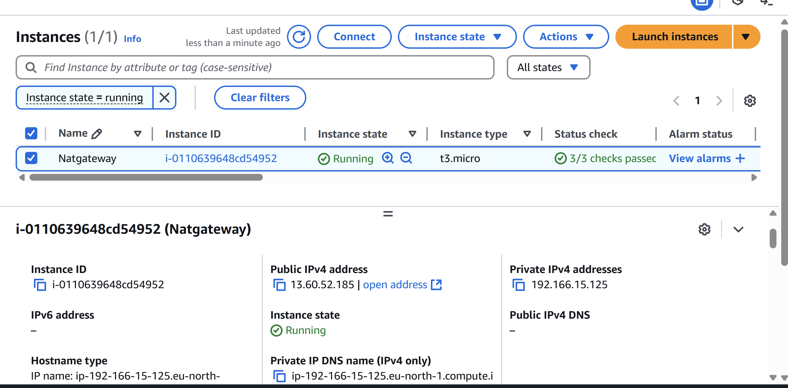

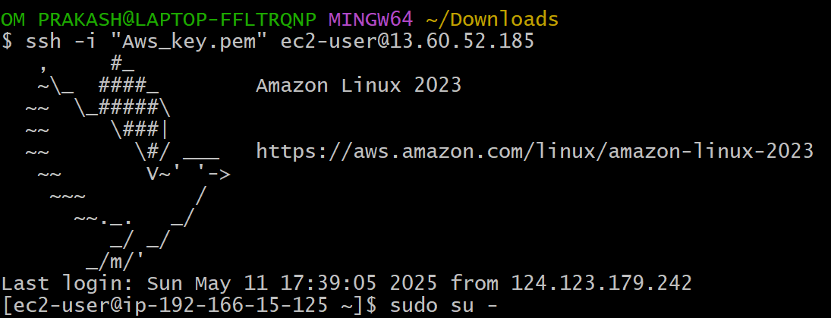

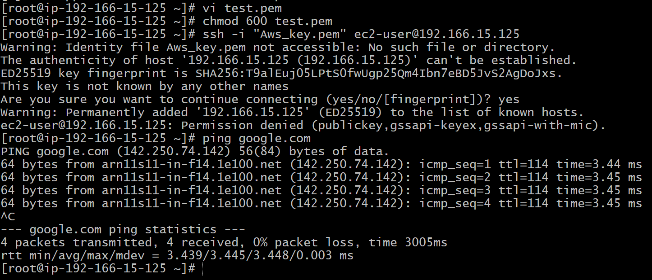

9) Install Apache Tomcat in private ec2 and deploy a sample app.

* Install Java (Amazon Corretto 17)

sudo yum update -y

sudo dnf install java-17-amazon-corretto -y

java -version

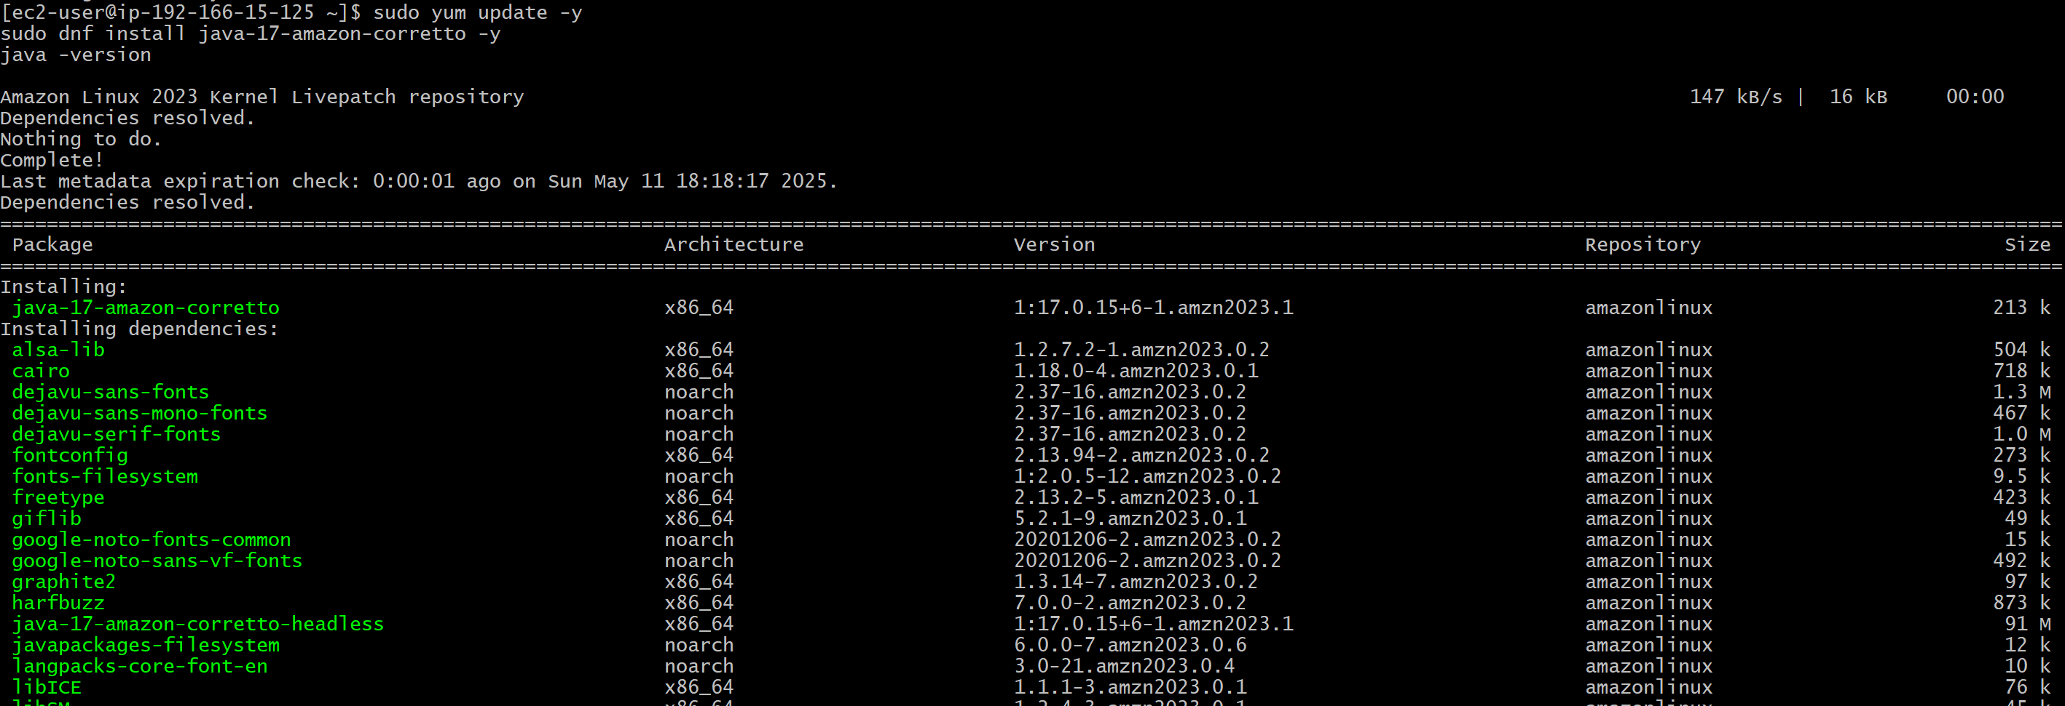

* Download Apache Tomcat 10.1.24

cd /tmp

wget <https://archive.apache.org/dist/tomcat/tomcat-10/v10.1.24/bin/apache-tomcat-10.1.24.tar.gz>

* Extract

sudo rm -rf /opt/tomcat/*

sudo tar -xvzf apache-tomcat-10.1.24.tar.gz -C /opt/tomcat --strip-components=1

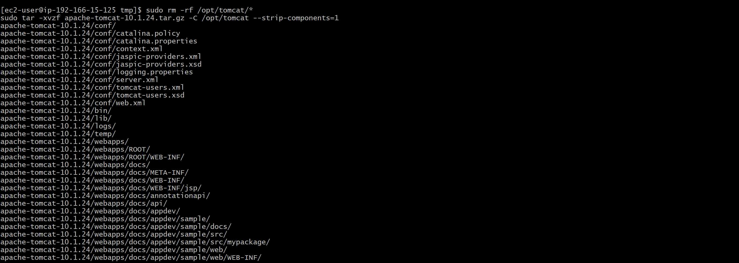

* List the files directly

sudo ls -l /opt/tomcat/bin

* If you see the .sh files (like startup.sh, shutdown.sh, etc.), then,
* Make the startup/shutdown scripts executable

sudo chmod +x /opt/tomcat/bin/startup.sh /opt/tomcat/bin/shutdown.sh

* Create a systemd service for Tomcat

sudo nano /etc/systemd/system/tomcat.service

* Paste the following content:

[Unit]

Description=Apache Tomcat

After=network.target

[Service]

Type=forking

User=tomcat

Group=tomcat

Environment="JAVA_HOME=/usr/lib/jvm/java-17-amazon-corretto"

Environment="CATALINA_PID=/opt/tomcat/temp/tomcat.pid"

Environment="CATALINA_HOME=/opt/tomcat"

Environment="CATALINA_BASE=/opt/tomcat"

Environment="CATALINA_OPTS=-Xms512M -Xmx1024M -server -XX:+UseParallelGC"

ExecStart=/opt/tomcat/bin/startup.sh

ExecStop=/opt/tomcat/bin/shutdown.sh

[Install]

WantedBy=multi-user.target

* Save and exit (Ctrl+O, then Enter, then Ctrl+X).
* Enable and start Tomcat

sudo systemctl daemon-reexec

sudo systemctl daemon-reload

sudo systemctl enable --now tomcat

* sudo systemctl status tomcat

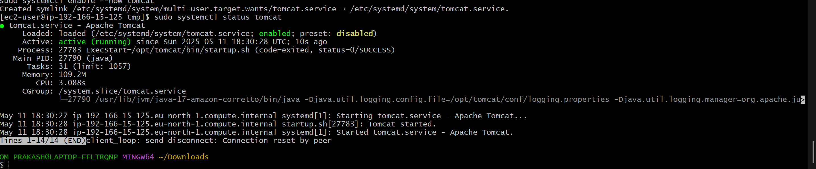

10) COnfigure VPC flow logs and store the logs in s3 and cloudwatch.

* Create S3 bucket

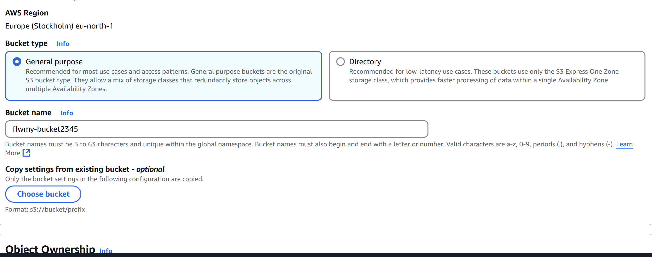

* Go to flow logs

